Task 3:- Image for the vulnerability scanning using Nessus

# Go to the nessus official website for the download

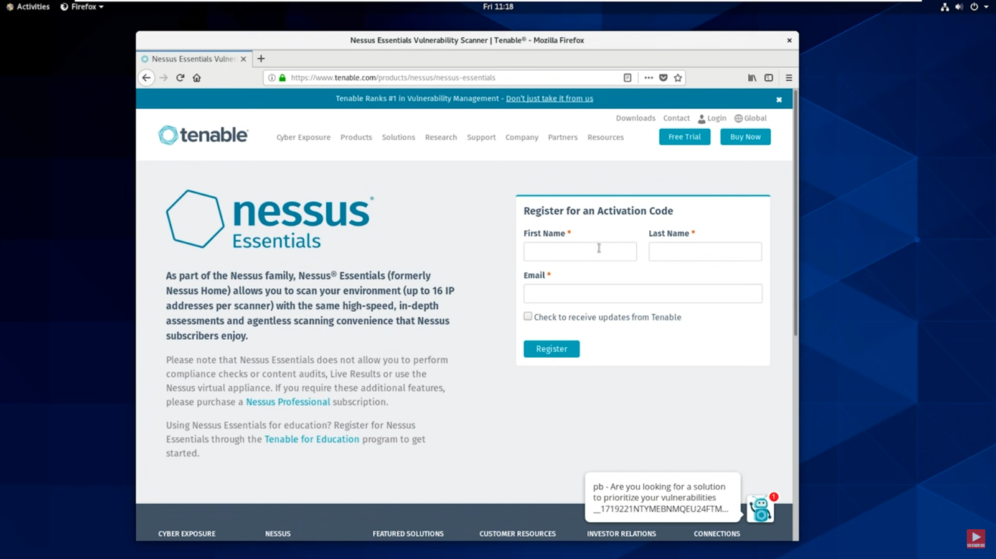

# Select the version suitable for the system

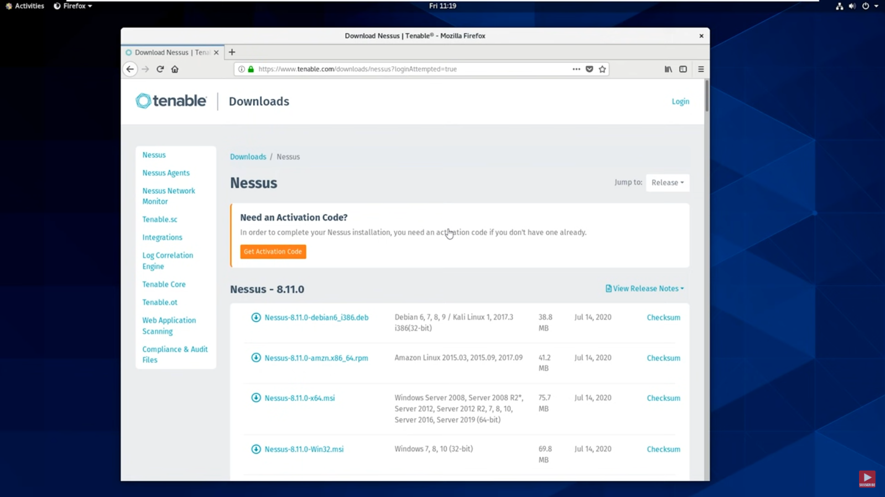

# Start downloading the nessus for vulnerability scanning

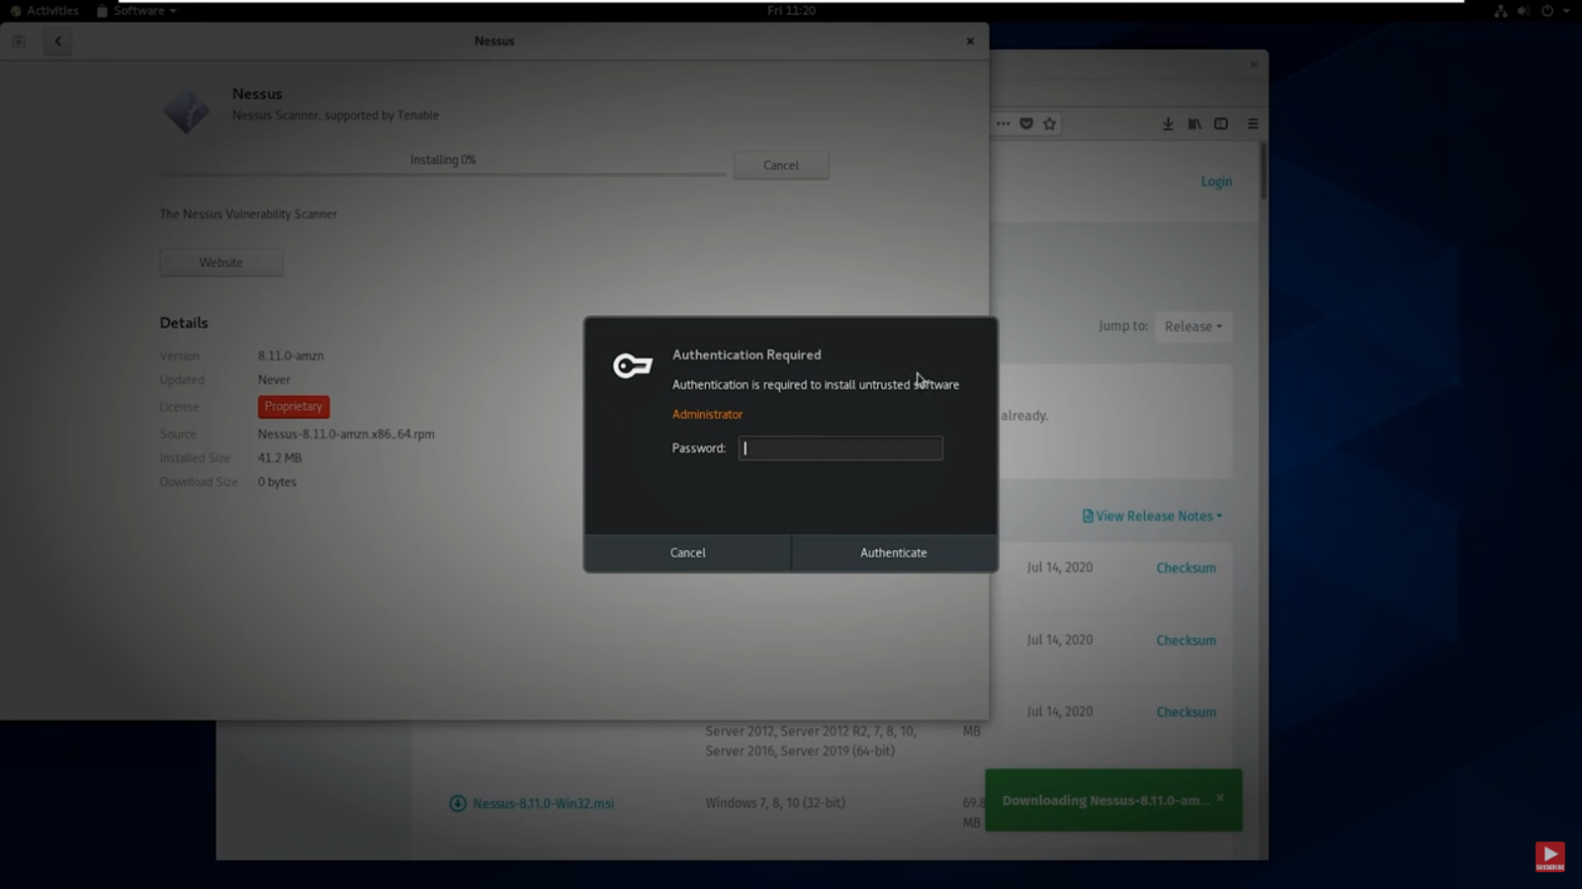

# After downloading the nessus , register to work on the scanning

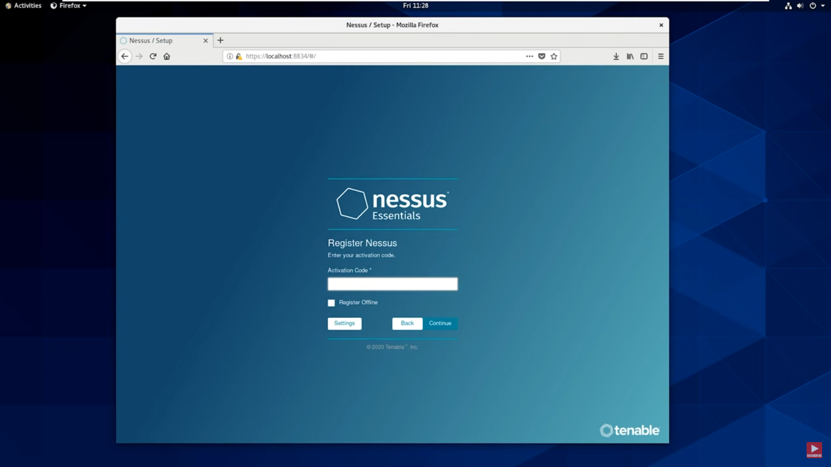

# After registering , it will enter into the home Page and it will ask for the ip address for the vulnerability scanning.

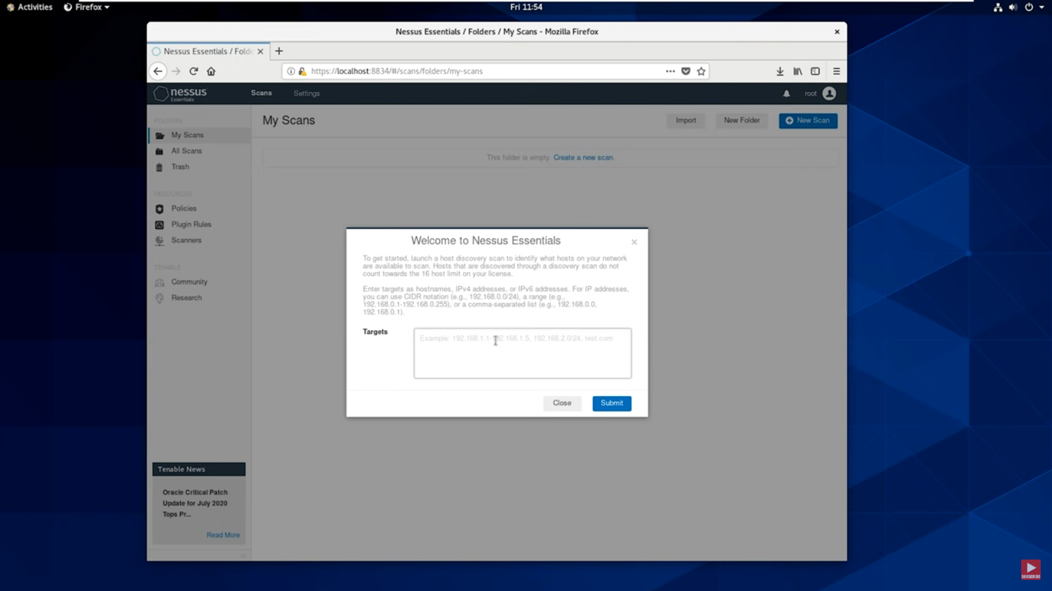

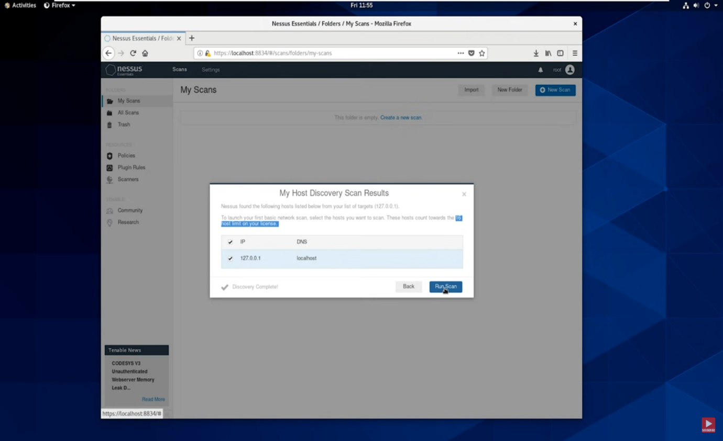# Select the correct IP address for the scan

# It will Scan for vulnerability in the network

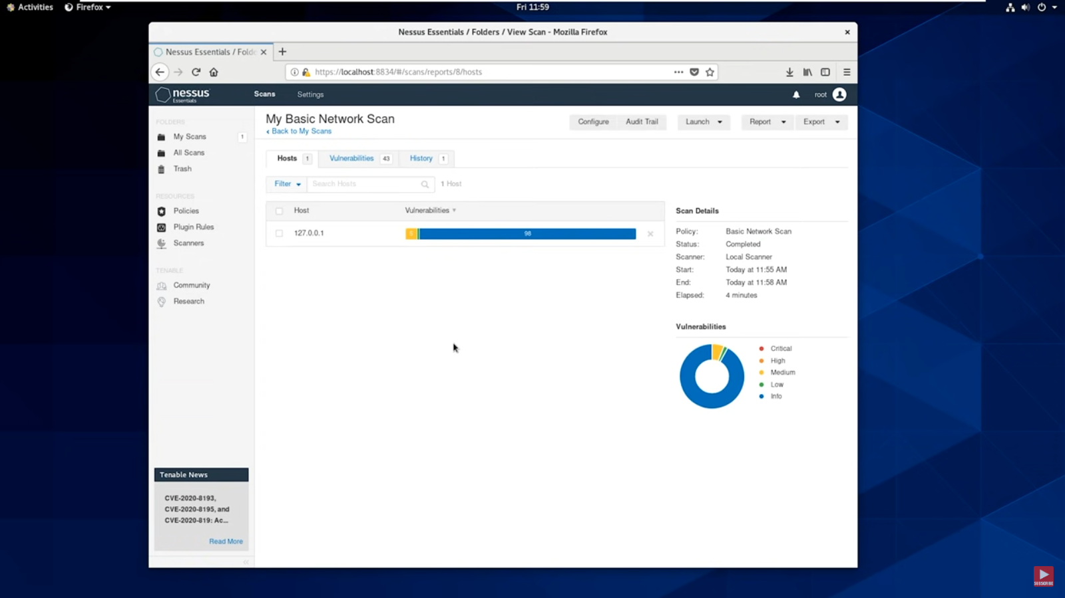

# Then it will show the all vulnerability in the network

